**In Cassandra DB,can we do grouping?**

Yes we can achieve grouping in cassandra by using GROUP BY

In GROUP BY Each set of rows with the same race_date column value are grouped together into one row in the query output.Using the GROUP BY option, rows can be grouped at the partition key or clustering column level.

**Note:**

* The GROUP BY option only accepts primary key columns in defined order as arguments. If a primary key column is restricted by an equality restriction, it is not included in the GROUP BY clause.
* Aggregate functions will produce a separate value for each group. If no GROUP BY clause is specified, aggregates functions will produce a single value for all the rows.
* If a column is selected without an aggregate function, in a statement with a GROUP BY, the first value encountered in each group will be returned.

### **Syntax**

From Apache Cassandra 3.10, it is possible for us to group either at the partition level or at the clustering column level.

| SELECT partitionKey FROM myTable GROUP BY partitionKey; |
| --- |

### 

### 

### 

### 

### 

### 

### **Example**

This is the table before applying group by

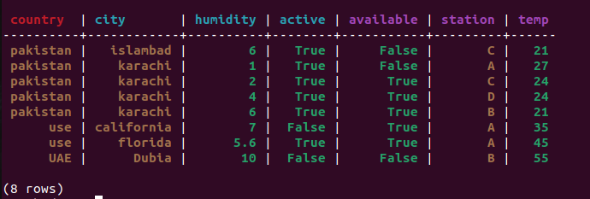

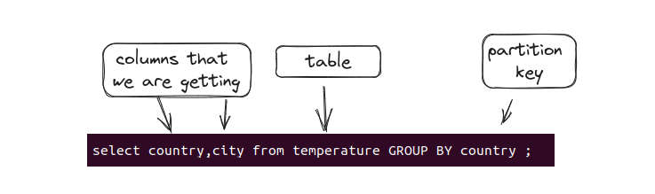

If the query run successfully you will see the result something like this

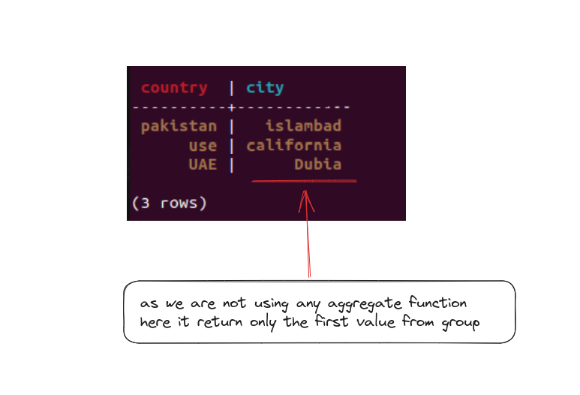

Here we have 8 rows in total but with GROUP BY the same value get into grouped and we left with 3 rows

**With aggregate functions:**

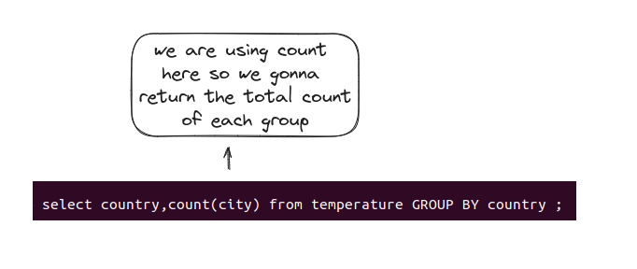

If the query run successfully you will see the result something like this

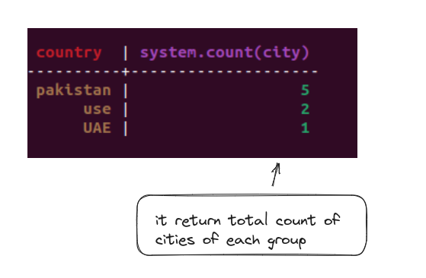

**Partition and Clustering key**

**Syntex**

| SELECT partitionKey, clustering0, clustering1, count(value) FROM myTable GROUP BY partitionKey,clustering0, clustering1; |
| --- |

### **Example**

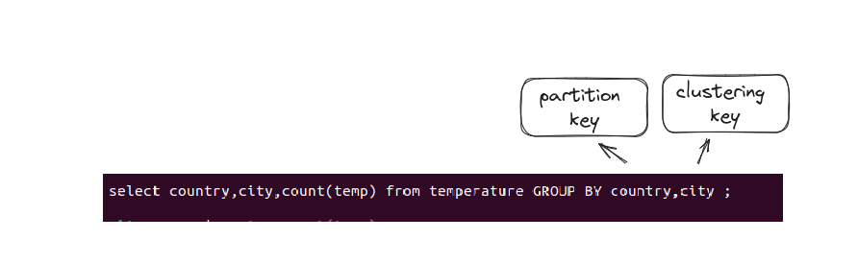

If the query run successfully you will see the result something like this

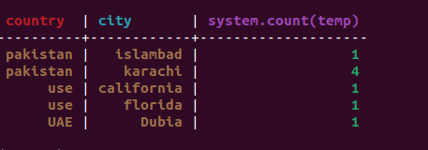

Now as you can see it is grouping data as per partition and clustering key both as pakistan has 5 rows in total but they are group in 2 cause there are 2 different cities(clustering key) and when we see cities we know that karachi had 4 rows and they are grouped but the count is representing the total count of rows or each group

Note:Cassandra 3.10 only supports group by with Partition Key or Partition Key and Clustering Key.